**Newsletter**

**22nd May 2020**

**Message from Mrs Hird**

As we reach the end of such an unusual half term, I want to start by saying a HUGE thank you to our incredible staff here at Glaisdale. I am so proud to be part of a team who have worked tirelessly to keep things going during the closures. As I’m sure you can imagine, there is a massive amount of work going on behind the scenes: Mrs Bennett is making sure payments are processed and all our administrative tasks are completed; Miss Tindall and Mrs Hustler are providing telephone and video calls and are working at the Airy Hill hub, along with Mrs Scholey and Mrs Laurence (who we are pleased to say has returned temporarily during this period!); Mr Russell and Mrs Mitchell are ensuring that every child has access to appropriate learning tasks and support; Ms Walker is making sure our buildings are maintained; and Mrs Freeman, Mrs Hirst and Mrs Perry are keeping up to date with the children’s progress through Facebook. We all genuinely miss your children and are eager to welcome them back to school, once it is safe to do so, and will continue to support from afar in the meantime.

I also want to extend my thanks to you and your children. I am sure there will have been ups and downs for everyone during the last few weeks but, as a staff, we have been so impressed with the efforts you and your children have made during these difficult times. We have loved seeing examples of work but have also been equally happy to hear about your (socially distanced) trips out in the great outdoors, fun in the garden and family time. As we have said all along, there is no pressure to complete the work that we are sending out and there is no ‘right’ way of dealing with the current situation – whatever works for your family is the right way!

Everyone working in schools knows that concentration and engagement can be challenging, particularly towards the end of a half term and I am sure some of you will have noticed that your child’s enthusiasm for learning may have tailed off during the last few days. This is perfectly normal and completely understandable given the current circumstances. We would encourage everyone to spend the next week, as far as possible, resting and recovering. Enjoy going for walks, sharing books, watching films or whatever activities you and your family love.

Have a happy and safe half term.

Mrs Hird

# **Dojo stars** Well done to the top 3 Dojo scorers

**Adventurers: Dalton, Sam W and Lottie**



**Explorers:** Star of the week goes to **Lydia** for her fantastic letter to the Owl Babies from mummy owl- well done!

**The Great Pea Growing Investigation!**

Well done to Chloe for her wonderful diary.

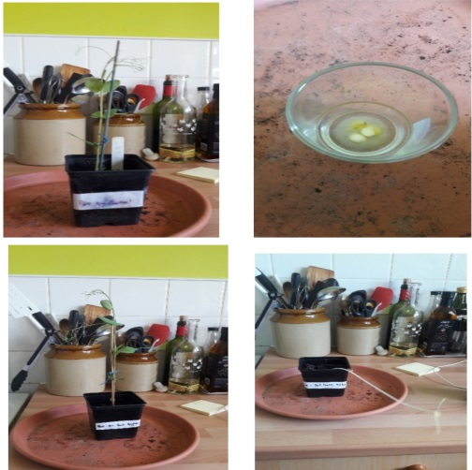

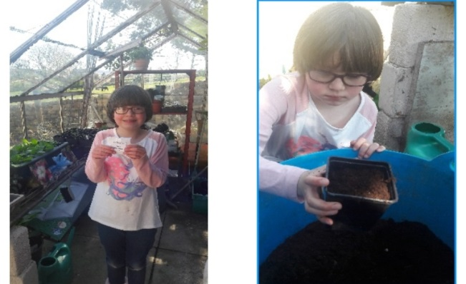

**News from the Explorers!**

We have all had a hoot in Explorers Class this week completing our Owl Babies activities! We have seen so many fabulous pictures of owls, collages, masks and letters. The children are working hard on their White Rose Maths and we have certainly had some super spellers this week too.

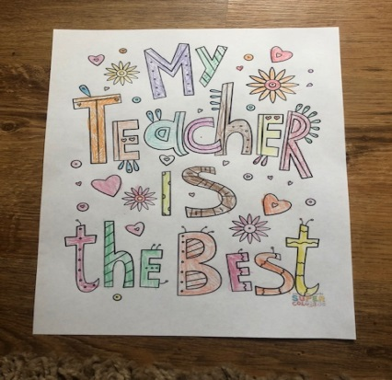

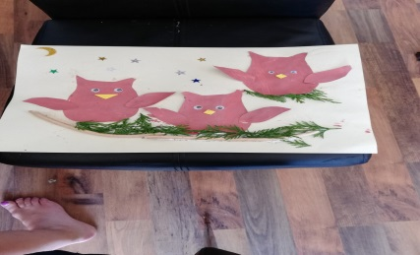

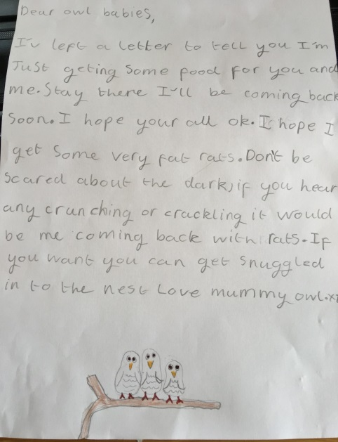

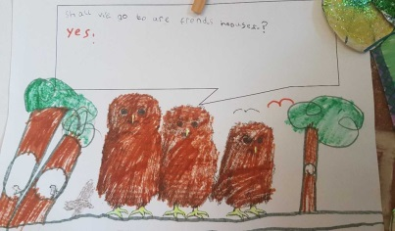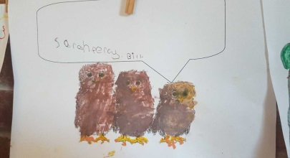

**News from the Adventurers!**

A Night in the Museum

Here are a few of Mr Russell's favourite extracts from Adventurer class' writing this week:

*In the Roman Room there was a smelly, ugly, greasy, 7 foot tall Roman king who murdered everyone who stood in his path. (Sam W)*

*He was the colour pine with vicious tiger eyes. Terror struck I wanted to run away but instead my legs were drawn to him like a magnet. (Molly)*

*Just as it stopped, I heard a strange crackling sound and then the ground shook like an earthquake! (Owen)*

A selection of exhibits to celebrate International Museum Day

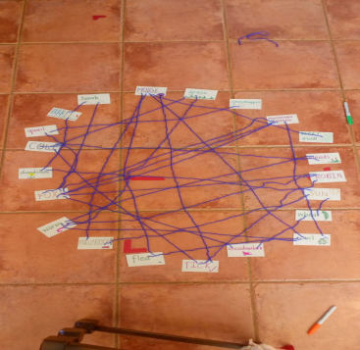

Ellie's foodweb

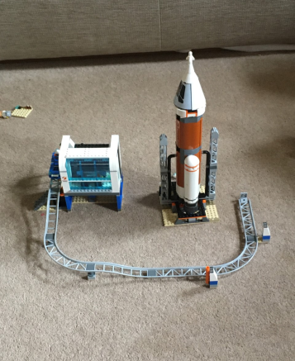

Thomas's LEGO space station

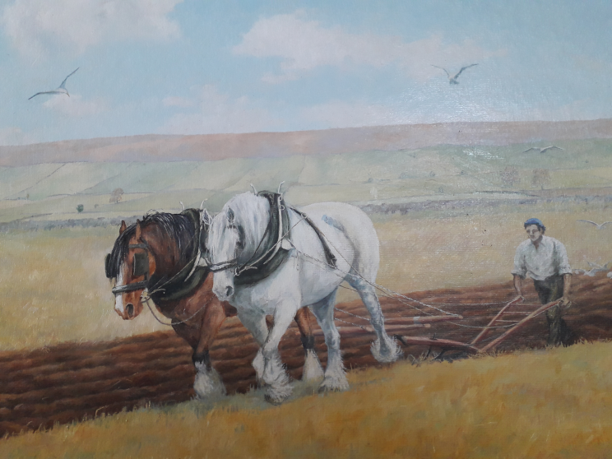

Lottie's Great Grandfather

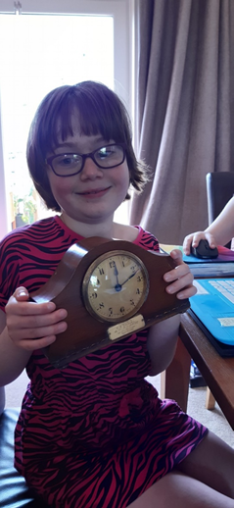

Chloe with a clock that belonged to her Great Grandad