**Newsletter**

**7th May 2020**

**VE day**

I'm sure that lots of you will be celebrating VE day tomorrow and would love to see photographs of your bunting, garden parties and decorated windows!



You do not need to register your child tomorrow and there is no expectation for them to send in any work (unless they really want to)! The emergency childcare provision will still be available at Airy Hill for families who require it.

**Video calls**

If you would like to receive a telephone or video call from your child's class teacher and/or teaching assistant, please complete the forms sent out previously and return them to Mrs Hird via headteacher.cg@yeat.co.uk

**Support**

We are pleased to have kept in touch with so many of our children and families during these closures, through emails, phone calls and video contact. We understand that every family is dealing with lockdown in their own way and want to reassure you that we are here to help. If you need any support, please do let Mrs Hird or your child's class teacher know and we will do all we can to help or to signpost you to resources or other organisations.

**New starters**

We have officially welcomed our four new starters, who will be joining Explorer class from September (assuming we are open). We can't wait until school reopens so that we can welcome them properly into the Glaisdale family.

# 

# **Dojo stars** Well done to the top 3 Dojo scorers in each class this week!

**Adventurers**

1. **Molly 2. Isla 3. Thomas**

**Explorers**

1. **Evanie 2. Jude 3. Lily**

.

**Work From Explorer Class**

What a busy, creative week Explorer Class have had! This week we have been basing our learning around The Magic Porridge Pot, we have seen some fantastic creative stories, pinch pots and ideas for new magic items from around the children's homes. We have also seen some fantastic spellings and maths. Well done for working so hard on your home learning again this week Explorers!

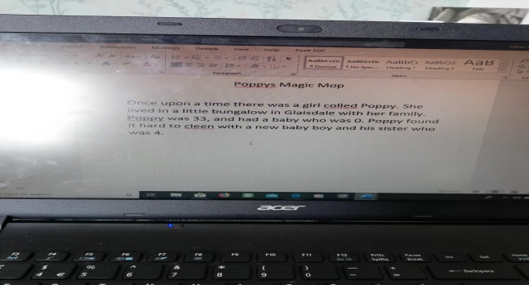

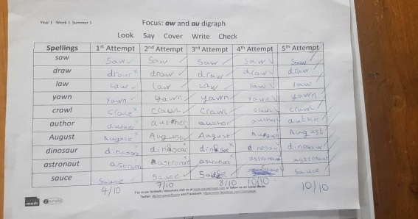

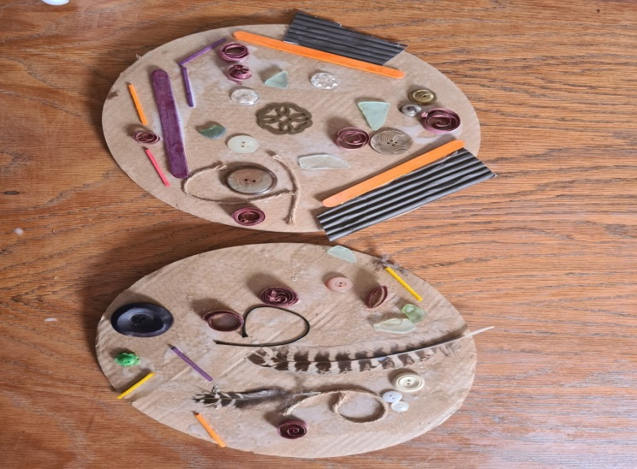

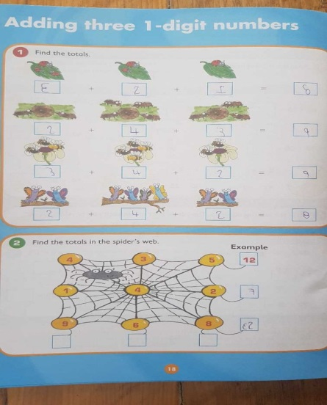

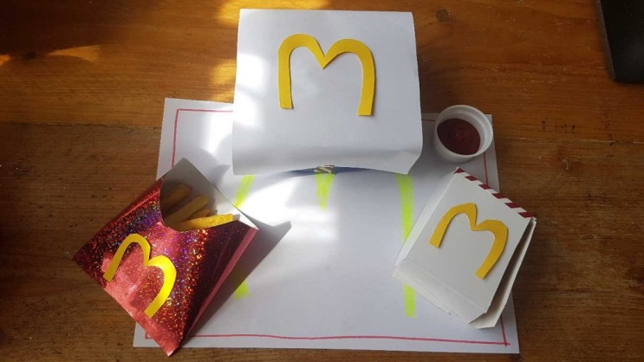

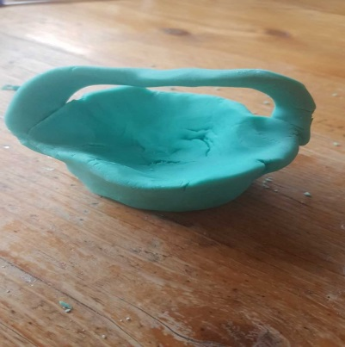

**Work from Adventurer Class**

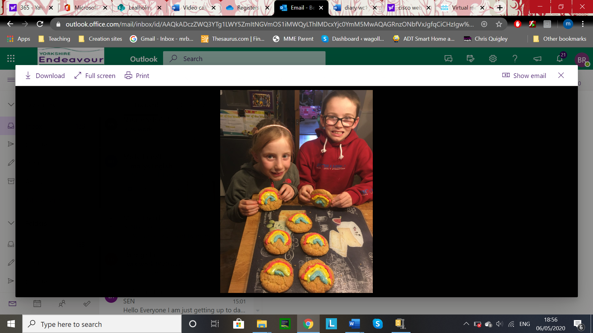

**Thomas and Molly’s rainbow biscuits**

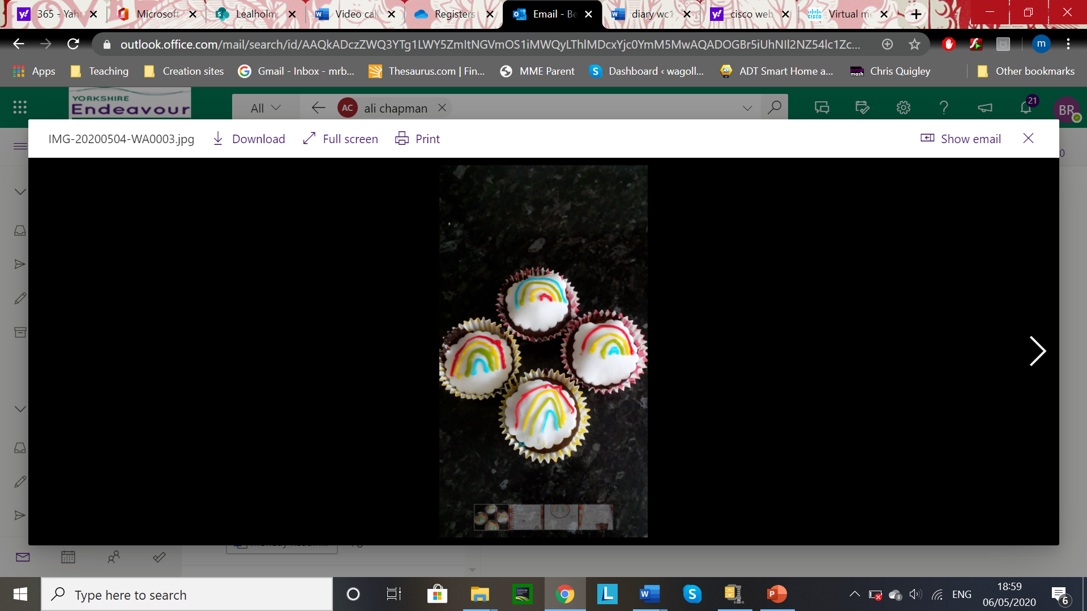

**Ellie’s rainbow cupcakes**

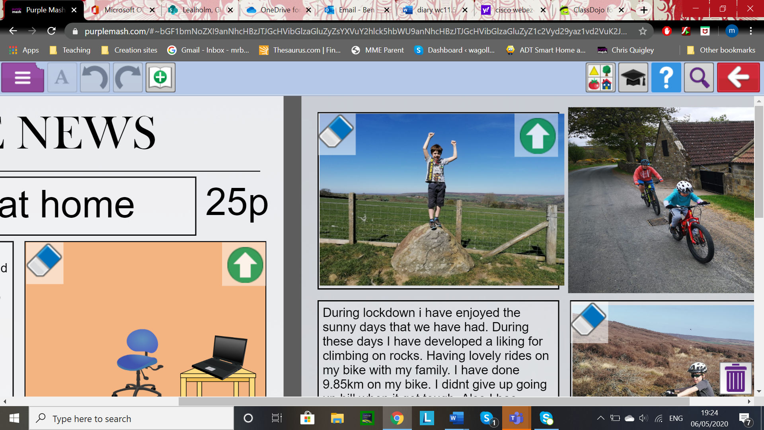

**A photo from Owen’s excellent Newspaper article**

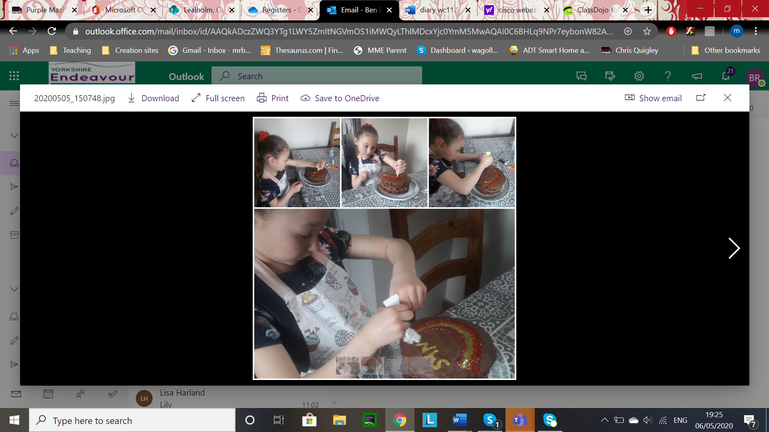

**Lottie decorating her Rainbow Cake**

**Emily and her dog wearing her home-made**

**face masks from this week’s DT task.**

