**Newsletter**

**15th May 2020**

**Message from Mrs Hird**

I have received several lovely messages from parents this week, recognising the efforts of our incredible staff team who are constantly working behind the scenes, whether this is organising home learning, making phone or video calls or staffing the hub for emergency childcare.

We are in the midst of the strangest times I ever hope to experience as a teacher and I am so proud to stand alongside the staff of Glaisdale.

Thank you for your continued support, it really does make a difference.

# **Dojo stars** Well done to the top 3 Dojo scorers in each class this week!

**Adventurers**

**Lydia Lily Jacob**

**Explorers**

**Ellie Sam H Chloe**

.

**The Great Pea Growing Investigation!**

I have been delighted that so many have taken part in the Great Pea Growing Investigation 🌱

I have received many emails, photos and messages telling me how the investigations have been prepared and carried out and the results are also coming in regularly. It has really interesting seeing how your different methods have yielded different results and it has given me lots to talk about when we can all return to school.

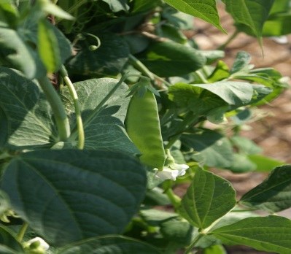

In the meantime, keep investigating, growing and recording your results so that you can make your own conclusions. If you feel that you have finished your investigation, then do plant your subjects (pea plants) outside with everything that they might need to try and grow healthy and strong and you may be rewarded with some peas later in the summer! Do be aware of any overnight frosts thought, as they really wouldn’t like that! - Mrs. Barber

**News from the Explorers!**

Another brilliant week of home learning for Explorer class. We have been busy learning about Van Gogh and his famous painting 'Sunflowers'. The children have been busy looking at flowers on their walks and in their gardens too. We have read some wonderful creative writing and postcards over the week! Well done everyone for all your hard work!

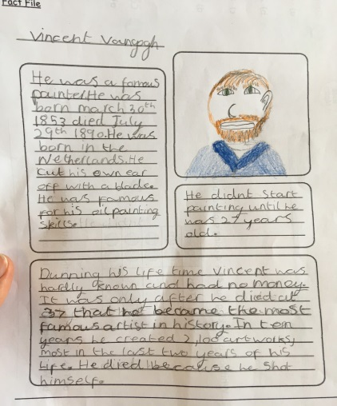

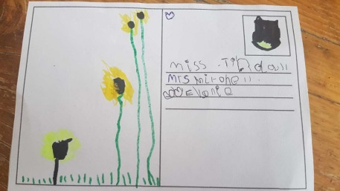

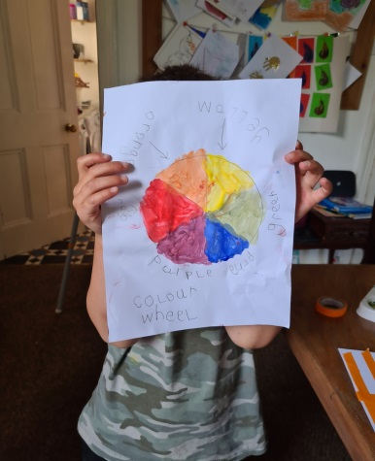

**News from the Adventurers!**

Top 3 in the UKS2 tennis tournament:

**Lily**

**Ellie**

**Oliver**



