**Newsletter**

**2nd July 2021**

**Message from Mrs Hird**

As you will have seen on our Facebook page, there have been lots of exciting learning activities taking place this week. Explorers had a fabulous trip to Whitby: the smiles on their faces show just how much fun they had! Back in school, Adventurers have been contributing to discussions in relationship education lessons, taking their maths learning outside and rehearsing for the end of year performance.

As we move into the final few weeks of term, there are lots of events taking place. We are delighted that our small size means we are able to include parents in our plans and I would like to thank you in advance for your support in following the COVID measures we are putting in place. We do hope that all events will be able to go ahead but appreciate your understanding if anything does need to change. **Mrs Hird**

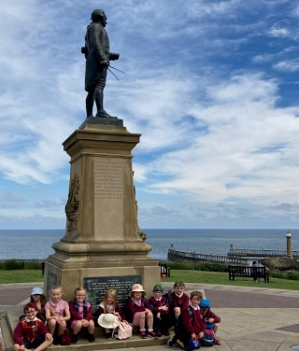 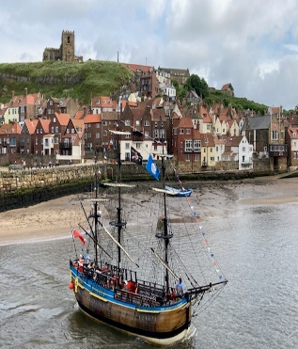

**Attendance**

Attendance this week has been lower than our whole school target of 97%, at 94.2%.

**Music news**

Congratulation to Finley who has received a Merit in his drum exam and Lydia, who has achieved her copper grade music medal for keyboard!

**Monday 5th July – Whole school trip**

On Monday we will be taking part in ‘Moors day’ at Blakey Ridge.

**All children are required to be in school for 8.45 and bring a packed lunch from home.**

Children may wear non uniform for this trip - please ensure they are in clothing suitable for outdoor learning and whichever weather presents itself this day! Sensible shoes, walking shoes or wellies are recommended - no sandals/ crocs/ open shoes please. Please could children bring a backpack each so they are able to carry their own packed lunch, water bottle as well as Sun hats, sun cream and coats etc.

**Our week ahead**

|  |  |
| --- | --- |
| Monday | **Whole school trip to Blakey Ridge ‘Moors day’** |
| Tuesday | **AM -Music lessons with Mrs Lillie**  **Craft club – afterschool until 4.15** |
| Wednesday | **New starters visiting EYFS - PM** |
| Thursday | **Sports day** |
| Friday | **Tag Rugby – afterschool club until 4.15 (PE kits required to change into)** |

**Next week’s Clothing requirements**

* Monday –Moors day clothing
* Tuesday - Uniform
* Wednesday - Uniform
* Thursday - PE Kits
* Friday – Uniform

**Dinner Menu w/c 5 th July 2021**

**Mon** ***WHOLE SCHOOL TRIP – PACKED LUNCHES FROM HOME***

**Tues** CHICKEN KORMA AND RICE

APPLE CRUMBLE AND ICE CREAM

**Weds** MINCED BEEF AND DUMPLINGS

STRAWBERRY JELLY

**Thurs** CREAMY CHICKEN AND BROCOLLI PASTA BAKE, CRISPY CEREAL BAR

**Fri** FISH FINGERS, CHIPS AND BEANS

CHOCOLATE BROWNIE

**Playgroup news**

The children at Glaisdale Playgroup are taking part in a sponsored walk around the village. Please visit their just giving page for further information and to donate

https://www.justgiving.com/campaign/glaisdaleplaygroup?utm_source=facebook&utm_medium=campaign&utm_content=glaisdaleplaygroup&utm_campaign=pfp-share&utm_term=e6676f90fe2f4cf4a6f183c0cb8e33a9

**Do you know someone who would like to join Team YEAT?**

We have three exciting job opportunities, starting in September 2021.

Team Glaisdale

1 x Advanced Teaching Assistant post (25 hours per week plus MSA hours)

1 x Breakfast club playworker (5 hours per week)

Team Castleton

1 x General Teaching Assistant (SEN) (5 hours per week, initially)

For more details, please visit NYCC jobs and search 'Glaisdale' or 'Castleton'

<https://www.northyorks.gov.uk/jobs-and-careers>

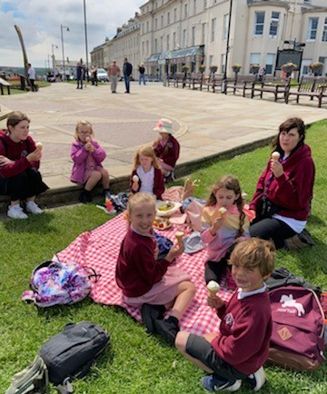

# **Summer term key dates**

* **Monday 5th July** – Whole school ‘Moors day’ trip to Blakey Ridge
* **Thursday 8th July** - Sports Day **Parents are reminded to submit their list of spectators to us ASAP and have been emailed details about restrictions.**
* **Friday 9th July** - Reserve sports day
* **Wednesday 14th July** – YR-Y6 East Barnby trip
* **Monday 19th July** – Y6 Leavers trip
* **Tuesday 20th July/Wednesday 21st July** – Year 6 transition to secondary school and in house transition days
* **Thursday 22nd July** – Summer concert 2pm
* **Friday 23rd July** – Last day of term

**11am** – Year 6 leavers assembly

Summer picnic lunch