Newsletter
3rd July 2020

Message from Mrs Hird

We’ve had another fantastic week of learning, both in school and at home. Thank you to everyone who has sent photographs into Mr Russell and Mrs Mitchell and well done to our children in school who have been working very hard. As you will have seen on our Twitter and Facebook pages, the children have been improving their sporting skills at the quarry, as well as working on their usual learning tasks.

Playgroup It has been lovely to hear the chatter and laughter from the children who returned to playgroup this week. There were some huge smiles when the children arrived for their first day back and I’m hoping that our new starters will be just as happy when they join Explorer class.

Transition You will have received an email about our planned transition events, which will take place in the final week of term. If you haven’t already done so, please can you contact school via headteacher.cg@yeat.co.uk or on 01947 897218 to confirm whether your child will be attending the transition sessions so that we can plan accordingly.

Reopening in September As you will have seen from the news, all schools will be open full time to all children from September and attendance will once more become mandatory. I will be in touch again next week to provide details of how this will look at Glaisdale and what additional safety measures we will be putting in place. I can't wait to finally have everyone back in school and look forward to getting to know our new families in the Autumn term!

Have a great weekend. Mrs Hird

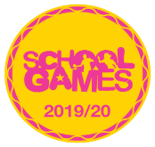

Sporting Success

Mr Russell has been working hard on our sporting provision and has lots of exciting plans for next year! This week we were thrilled to receive a School Games recognition certificate and a School Games badge, which have been awarded to the school in recognition of our commitment to, and engagement in, School Games events over the Autumn and Spring term 2019-2020. Well done to all our pupils whose commitment to sport this year has made this possible.

Sports Day 2020
We are hoping the rain doesn’t spoil play and we get lots of lovely photos and videos of your sports day attempts – please send them all in by Wednesday afternoon.

Times table Rock stars
Don’t forget to send your entries for the record attempt, to Mr Russell by midday next Friday 10th July.

Our Week (in and out!) of school

Year 6 On Tuesday, Year 6 had a visit from Miss Harrison, the KS3 Director of Learning at Caedmon to talk about their transition to secondary school. They’ve also been out on their bikes enjoying some socially distanced exercise in the playground.

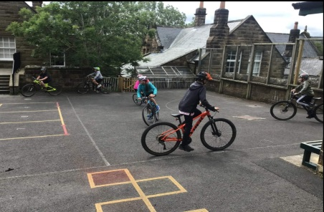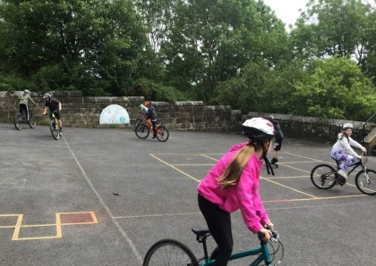
We hope you all enjoyed the video of our #stayathome ‘Rounder’s challenge’ by Rounder’s England – the children and staff in school had a great time at the quarry practising their skills for our entry. If you have entered from home, we would love to see your videos or photos!
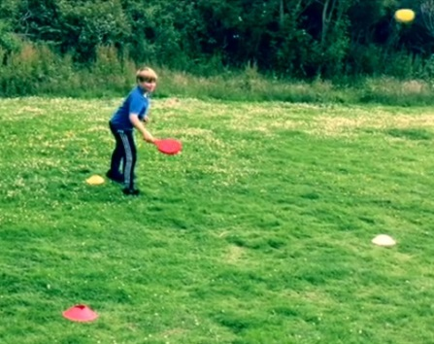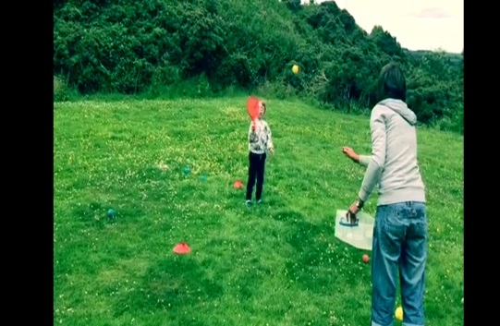

Explorers have had a very crafty week this week, we have seen lots of fantastic photos of ladybird artwork. The children have been using household objects, paints, papier-mache and even eggs to create their mini-beasts! We have also seen some wonderful written work: the children have been busy writing newspaper reports about the attempted farmyard robbery in our focus book ‘What the Ladybird Heard’ as well as some super 'wanted' posters to help catch the thieves from the story.

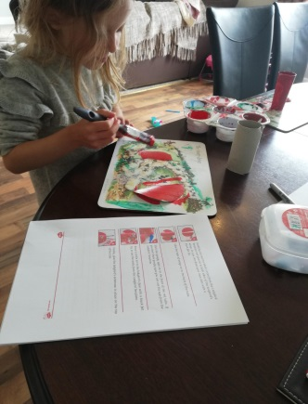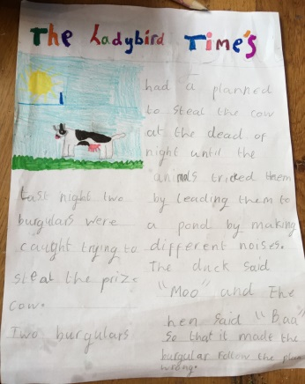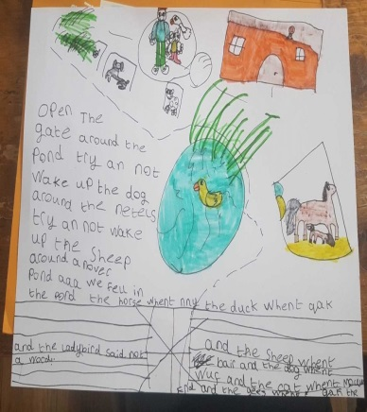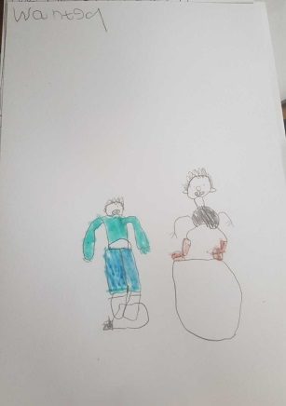

Our Star of the Week this week goes to Evanie, who has been coming on leaps and bounds with her letter formation recently because of all her hard work. Well done Evanie!

Help and Support
The government have produced advice to parents on keeping children save during the pandemic. The link below includes lots of information and links to other resources. Some may not be relevant to your family but the areas linked to online safety and mental wellbeing may be of particular use.
https://www.gov.uk/government/publications/coronavirus-covid-19-keeping-children-safe-from-abuse-and-harm/advice-to-parents-and-carers-on-keeping-children-safe-from-abuse-and-harm#mental-health

Message from the Governing Body

Dear Parents/Carers

I hope this newsletter finds you and your family safe and well. I wanted to take this opportunity to give you a brief update on what we, as governors, have been doing in recent times. Although we have not been able to meet up in person, we have been making use of video conferencing platforms so that we have been able to continue with our governing body meetings and have also been able to support in staff recruitment in this way. Since our schools reopened after May half term, two governors have ‘virtually’ met with Mrs Ward and Mrs Hird each week to review the arrangements for our children and to discuss any changes and/or plans for these arrangements ahead of the weekly meeting between the head teachers and representatives of the Yorkshire Endeavour Academy Trust board.

On behalf of the governing body, I would like to say thank you to the tremendous team of staff we have who have been working tirelessly both in the classroom and from home to provide our children with learning opportunities and pastoral support. It has also been fantastic to see the staff from across the three schools working so well together as one team.

I appreciate that recent months will have presented some huge challenges for many of our families and we are very grateful for the support which we have had from you during these ever-changing times. I also recognise that many parents and carers will have concerns about the impact this disruption has had on the education of their children as well as on their emotional and mental wellbeing. When our schools do fully reopen, the governing body will do everything it can to support our staff in ensuring a smooth return for our children and will be closely monitoring the activities in place for identifying and closing any gaps in pupils’ knowledge and understanding.

We are very much looking forward to having all three schools open and thriving once again.

Lou Margetts

Chair of Governors

