Newsletter
15th January 2021

Message from Mrs Hird

Thank you for your continued support with our blended learning offer. Your child's class teacher will have provided you with details of their daily timetable and the overview of our offer can be found on the 'Covid' page of our website. It has been lovely to see so many photographs and pieces of work sent through via either Tapestry of Class Dojo and I know the staff have enjoyed engaging with pupils via Zoom.

We believe that our offer is a strong one, giving children the opportunity to access learning relating to a wide range of curriculum areas. We encourage all pupils to engage as fully as possible. If you are experiencing any difficulties or would like any support with your child's learning, please do let their class teacher know and we will be in touch.

Once again, I would like to extend my thanks to our incredible staff team, who continue to work flexibly and enthusiastically in these challenging times. I am sure you will agree that they are doing a fantastic job! Take care

Mrs Hird

Key worker provision

Your child may have mentioned that staff are wearing face masks at certain points during the day. This is due to a change in our risk assessment, the updated version of which can be found on the 'Covid' page of our website. In line with the guidance for primary schools, staff will not be wearing masks whilst teaching or supporting children in class.

Snow

Thank you for your patience with us during the snowy weather. The decision to close school is never an easy one to make, particularly as we know our key workers are depending on us. However, the vast majority of our staff live beyond the village (some travelling quite a distance to get to school) and we have to take into account the road conditions and staff: pupil ratios in order to keep everyone as safe as possible.

In situations where we do make the decision to close, we will endeavour to ring parents accessing the provision at the earliest possible opportunity and will also post messages via Facebook. If the closure happens during the school day, please note that we will always ensure that pupils are adequately supervised until someone arrives to collect them. Please could we ask all parents currently accessing the key worker provision to ensure that we have your most up to date contact details, both for first thing in the morning and during the school day.

Peat Rigg Y5/6

It is with great reluctance that we have had to take the decision to cancel our shared residential to Peat Rigg in May with Y5/6. This decision has not been taken lightly and we are fully aware of the huge disappointment for our children. However, we feel that it is highly unlikely that we will be able to mix 5 schools together at that time. We will instead seek some other exciting activities to take part in, guidance and risk assessments permitting

Message from the Chair of the Trust

I hope that you and your families are staying safe. As we go into the second week of schooling post Christmas, I hope you feel that your needs as a parent/carer have been considered and you are confident in the commitments we have made to both the quality of your child’s education and to their health, safety and wellbeing.

YEAT schools received DfE guidance late last week and have worked tirelessly to ensure that provision offered is equal to or better than the requirements set out in the documents.

In balancing a) the need to provide places for our most vulnerable learners and children from households where only one parent or carer needs to be considered a key worker to qualify for a school place, and b) our commitment to ensuring that our schools operate safely for all staff, we believe we now have a solution.

To maintain nuancing appropriate to each school and each class within a school, our proposal is that the number of students taught on site is to be determined by the size of room. In taking this approach rather than simply capping at a set number, classes should not feel crowded and staff and students will have space to operate at a distance. Headteachers will of course provide a fuller picture and how this relates to your child. [The number of pupils requiring key worker provision at our school are sufficiently low at present that we will be continuing our provision as it currently stands. As stated previously, if you no longer need to take up a space, or are able to move to part time provision, please do let me know. Mrs Hird].

These are challenging times and there are no simple answers to the complex issues we need to address collectively as team YEAT. I suspect that for some time yet our schools will need to operate mindful of health concerns relating to COVID. As you have been doing, please maintain an open and honest dialogue with staff who are always keen to reach mutually agreeable solutions within the rules set out by DfE .

Can I thank you all once again for your willingness to work in partnership with the schools and only taking up places that are absolutely required. By helping us to keep student numbers at manageable levels our first priority.

Mathew Brown

Chair of Trust Board

Music children who have opted to continue their music lessons with Mrs Lillie via Zoom have got off to a great start this week. We are delighted to hear that Thomas is submitting his entry to the Whitby Young Musician competition this week – this is a fantastic achievement and we wish him all the very best of luck with his entry.
If you would still like for your child/ren to continue with their lessons during the lockdown, please email us on admin.glaisdale@yeat.co.uk. Thank you

Explorers The wintery weather this week has been perfect for Explorer Class as we have been learning all about hot and cold and making our own weather observations for our Seasons science topic. The children have been busy learning the words and actions to our Tiddler story all week and will be making their story maps soon. Well done to all the children for attending our Zoom phonics sessions! Mrs Mitchell
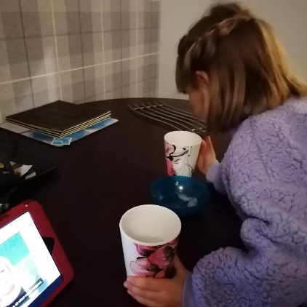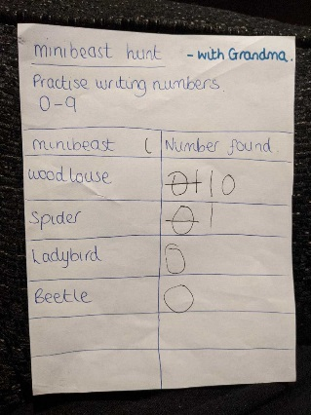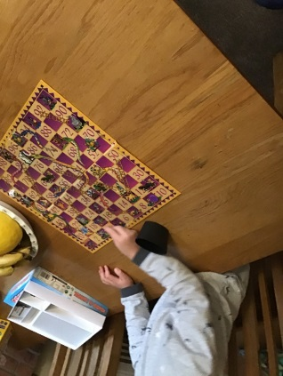

Adventurers For our writing, we have been imitating a story called, “Kidnapped”. We’ve made actions to go with the text and drawn story maps to help us memorise it. We’ve also made ransom notes and some children have even role played the story.
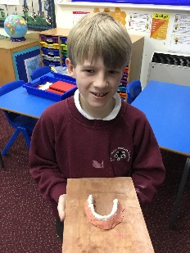
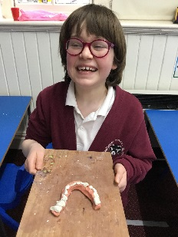
The children in school have also been working incredibly hard. Chloe and Fin really enjoyed making models to demonstrate the different sorts of teeth! Mr Russell

